AWS IAM Cloud Security Project

1. Project Overview
I completed this project on cloud security controls in Amazon Web Services (AWS), focusing on Identity and Access Management (IAM). The goal was to create a least‑privilege policy, attach it to a user group, and verify that the policy correctly restricts actions on two Amazon EC2 instances (audit and sales).
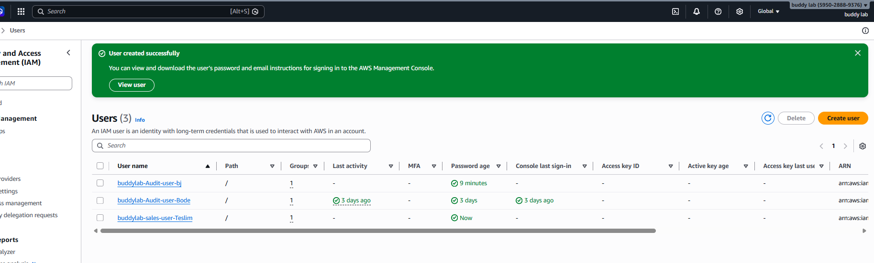

2. Tools & Concepts
- AWS IAM – users, groups, policies, account alias
- Amazon EC2 – instance tagging and lifecycle actions
- JSON policy syntax – Effect, Action, Resource
- Principle of least privilege and policy testing

3. Tagging Strategy
I applied a descriptive tag to each EC2 instance:
Instance | Tag Key | Tag Value
Marketing | Environment | Audit
sales | Environment | Sales
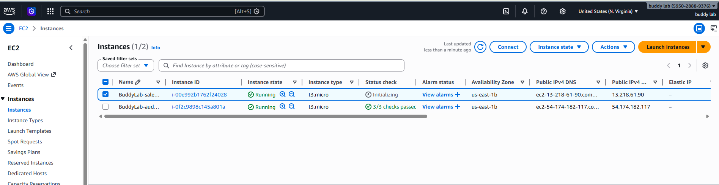

4. Creating the IAM Policy
I authored the following JSON policy to block instance stop/start actions on the audit server but allow those actions on the sales server:
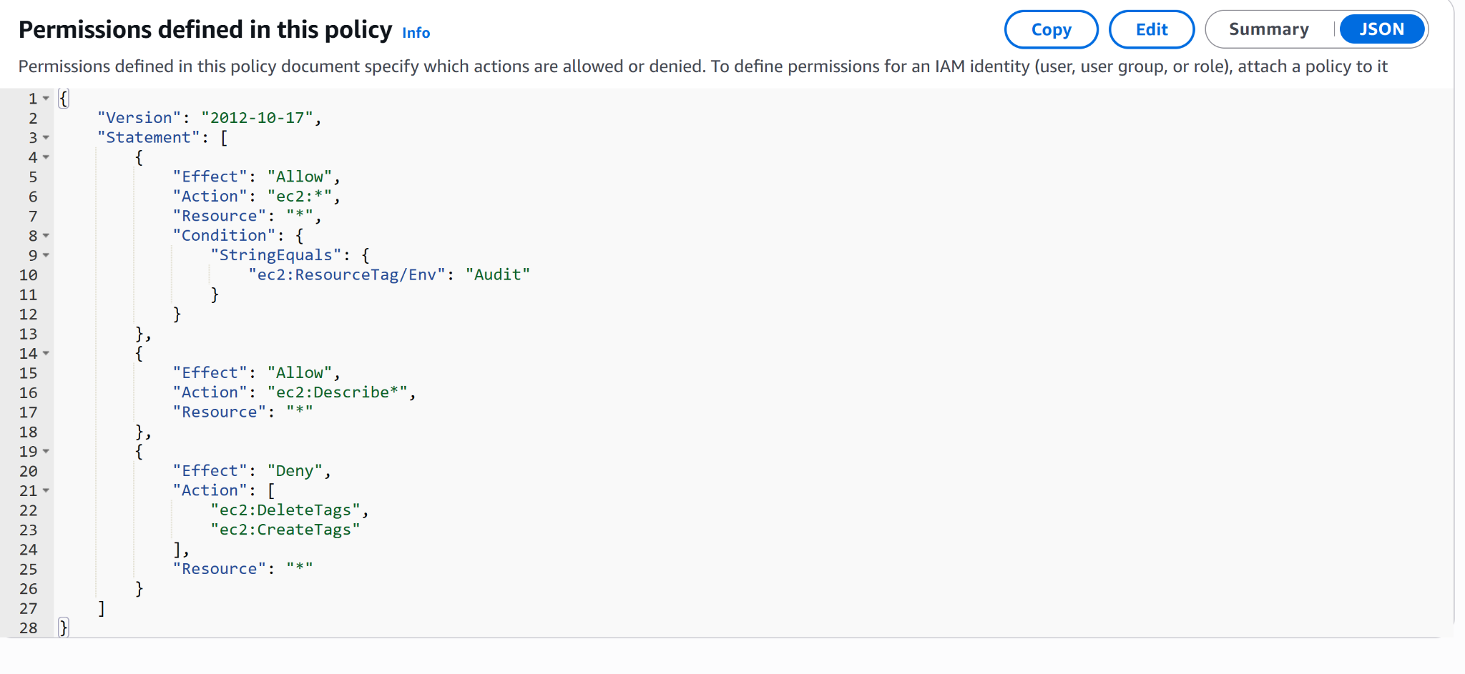

5. Account Alias
I set a memorable account alias to replace the default numeric URL, making sign‑in easier for team members.
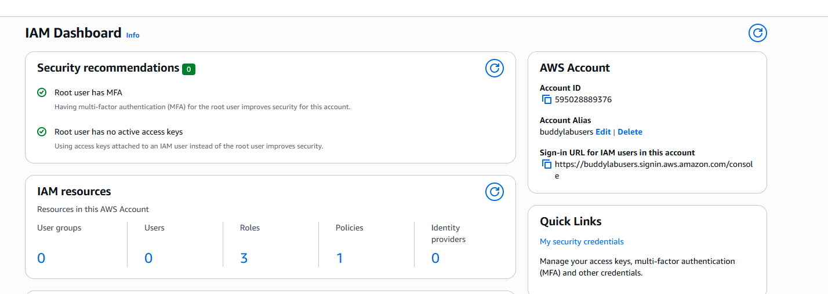

6. IAM Users & Groups
1. Created an IAM user group called Developers.
2. Attached the CyberAuditEnviromentPolicy policy to the group.
3. Added individual IAM users who require controlled EC2 access.
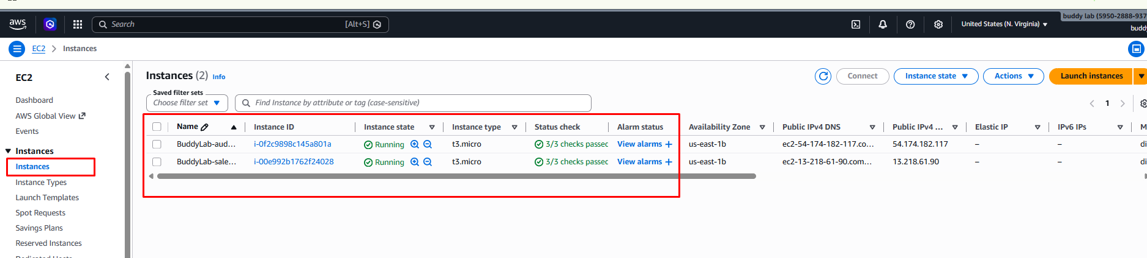

7. Logging in as an IAM User
IAM users can sign in through:
- AWS Management Console (using the new alias URL)
- AWS CLI via programmatic keys
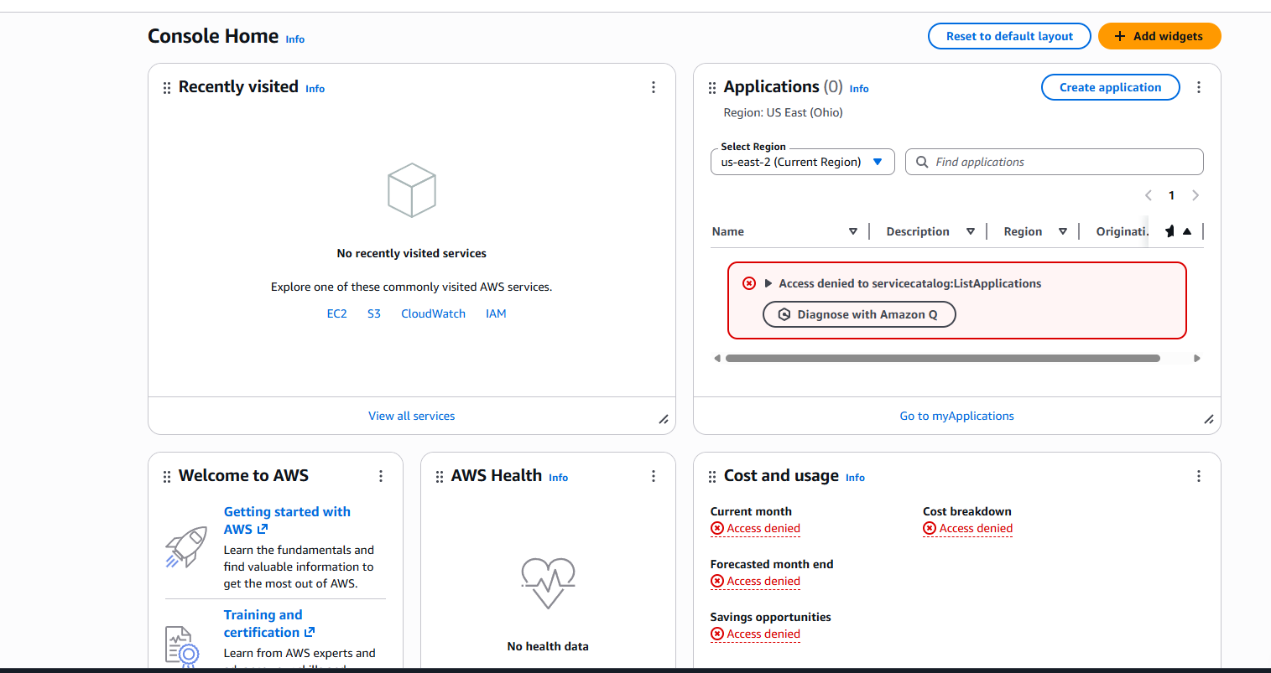

8. Testing the Policy
Test Action | Expected Result | Actual Result
Stop audit instance | Denied | Access denied error displayed
Stop sales instance | Allowed | Instance stopped successfully
Start audit instance | Denied | Access denied error displayed
Start sales instance | Allowed | Instance started successfully
